Note-taker using a PS/2 keyboard
Individual Project Report

Embedded Systems - CSE537

Arjun 2008011

- Synopsis
This project interfaces the board with a PS/2 and an external SD card, allowing the system to be used for taking rough notes during, say, classes. This system helps people who find typing easier than writing. However, this system provides only a rough implmentation, with several implementations. It is supposed to be used for fast-typing, with error corrections made later through a separate text editor instead of this system.

- Architecture
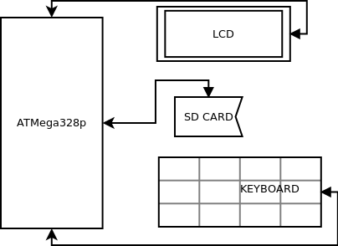
The microcontroller is interfaced with an LCD, an SD card reader, and a PS/2 keyboard.
- Hardware
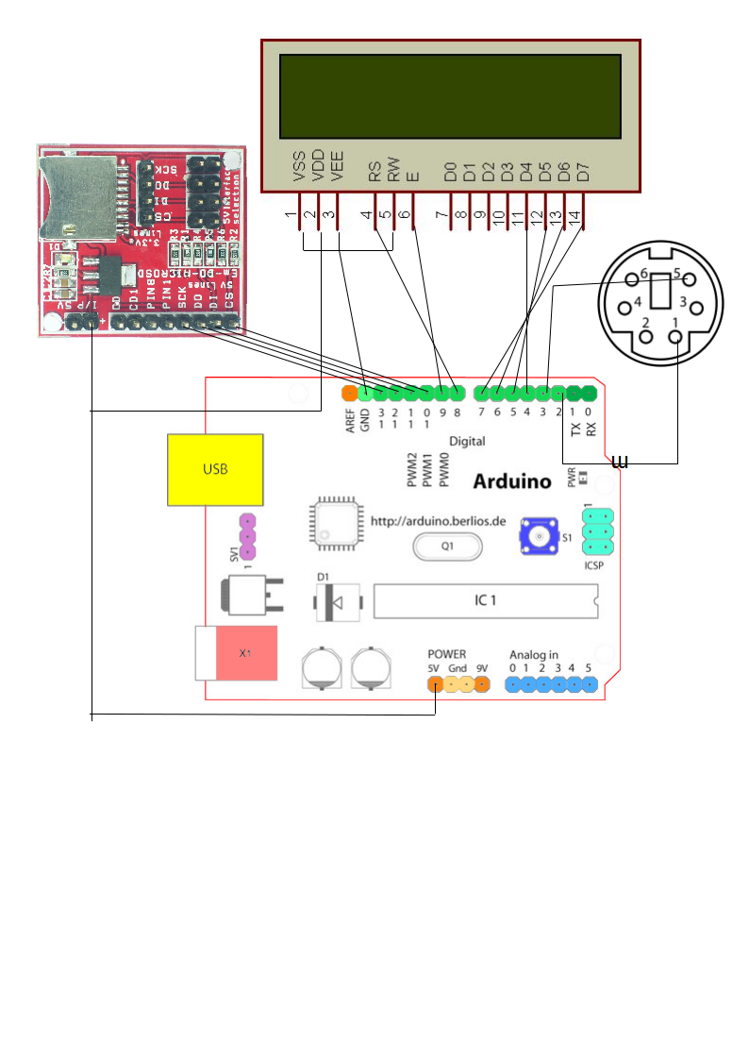
- Software
I use the Arduino project to program the microcontroller.The microcontroller is interfaced with the keyboard using the PS2Keyboard library, with the SD card using the Arduino SD library and with the LCD using the Arduino LiquidCrystal library.
The software works by initially asking the user to input a filename, which it then opens on the SD card. After opening the file, whatever the user types is written to the SD card until the ESCAPE key is pressed, due to which the file is closed and the user is again prompted for another file name.

- Learnings
I learned how to access the SD card, and I learned about the PS/2 protocol. I also learned about keyboard scancodes, and that hardware can be unreliable sometimes (mostly due to faulty connections). I also learned that connecting a 3.3v device (eg. 6610 LCD) to a 5v device (eg. ATMega328p) can destroy that device.

- Challenges faced
The major challenge I faced was getting the 6610 LCD to interface with the microcontroller. This turned out to be fruitless, since I had burned it out by connecting it without resistors to the microcontroller. The other challenge that I faced was that sometimes my microcontroller would recieve incorrect values from the keyboard, which was fixed by a reset. However, since I could not put the entire scan code table, there are still many keys which cannot be used on the keyboard.

- References
  - http://www.practicalarduino.com/projects/ps2-keyboard-or-mouse
  - http://www.embeddedmarket.com/products/Micro-SD-card-Interface-Breakout-Module-for-3-3V-and-5V-Logic-Level/?cur=USD
  - http://arduino.cc/en/Reference/SD

